LAB 321Assignment | Type: | LongAssignment
 | Code: | J3.L.P0011
 | LOC: | 600
 | Slot(s): | 15

Title: Blogging about my life

Background

A weblog (blog) is a website that contains a log or diary of information, specific topics or opinions. Blogging has become one of the more popular pastimes on the internet. Some people blog for money, others blog about current events, and others blog for humor. The list goes on. Increasingly, bloggers are use weblogs as a personal journal, preferring to keep it out of the spotlight. If you're someone who wants to start a personal blog, it's really quite easy. Try to finish this assignment with the help of mentors.
Reference site: http://us-123my-life.simplesite.com/

Program Specifications

Program a web blog to make your diary online, detail functions of this website is described below

Features:

This website contains 4 main functions
- Function 1 : Home page : ( see PIC 01 + PIC 02)
  - Display top 3 entries sort by published date
  - Each entry contains
    - Entry name
    - Description picture
    - Entry content
    - Published date
- Function 2 : Overview page ( see PIC 03)
  - Display all entry (title only) , sort by published date
- Function 3 :Entry detail ( see PIC 04)
  - Display entry detail
- Function 4 :Display about me page ( see PIC 05)

You do not need to write interface for admin control panel, you can add data manually (use SQL SERVER Management studio).
Note: All data must be load from database, not hard code in page.

Expectation of User interface:

Pic 01 : Home Page ( TOP)
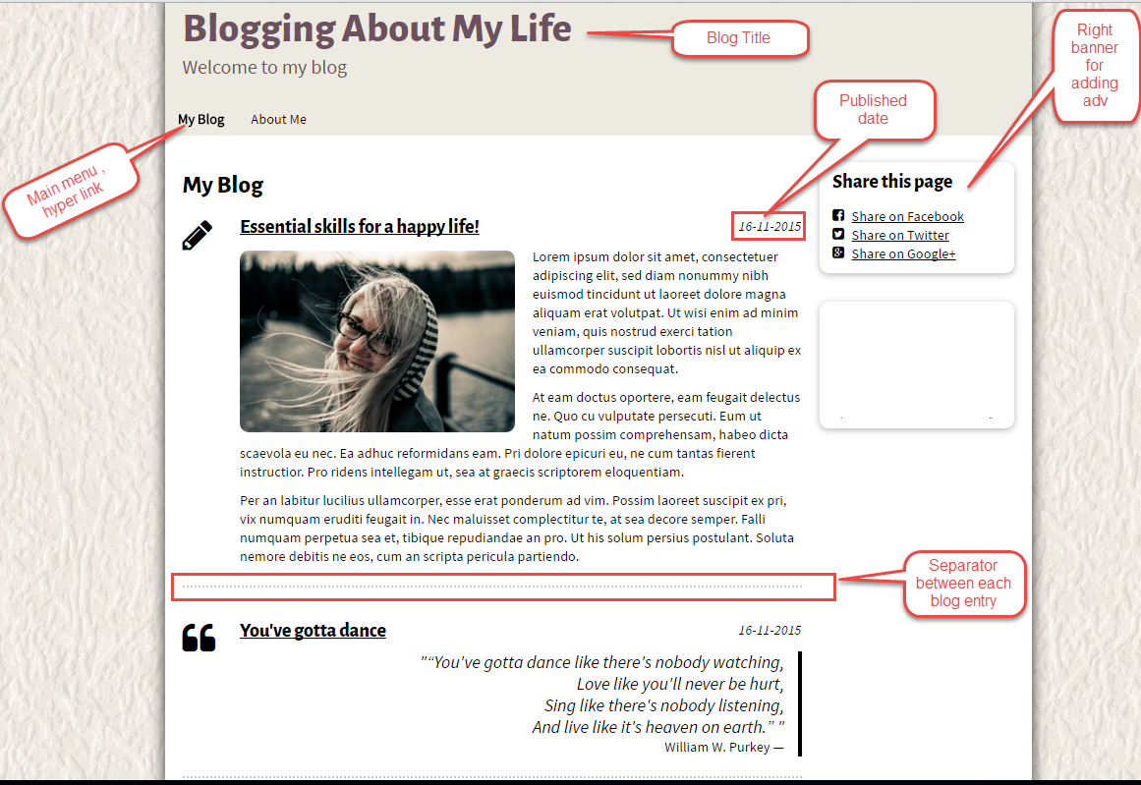

Pic 02 : The bottom of home page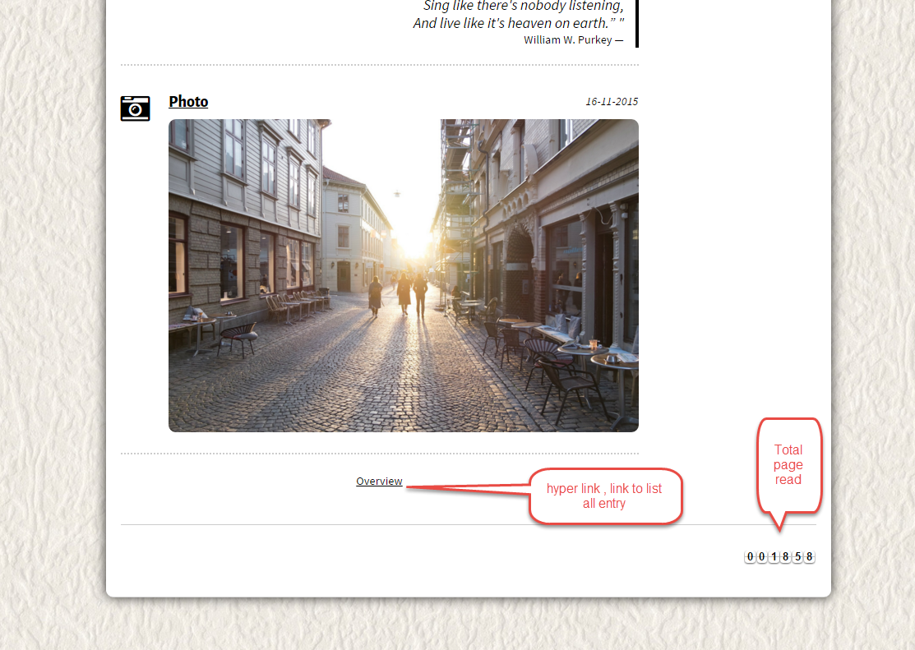

PIC 03 : Overview Page
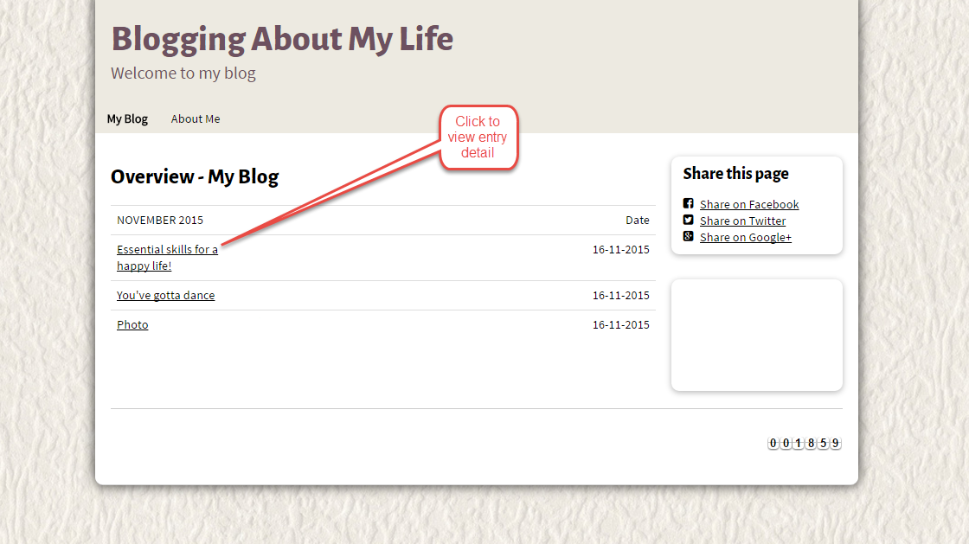

PIC 4 : Entry Detail

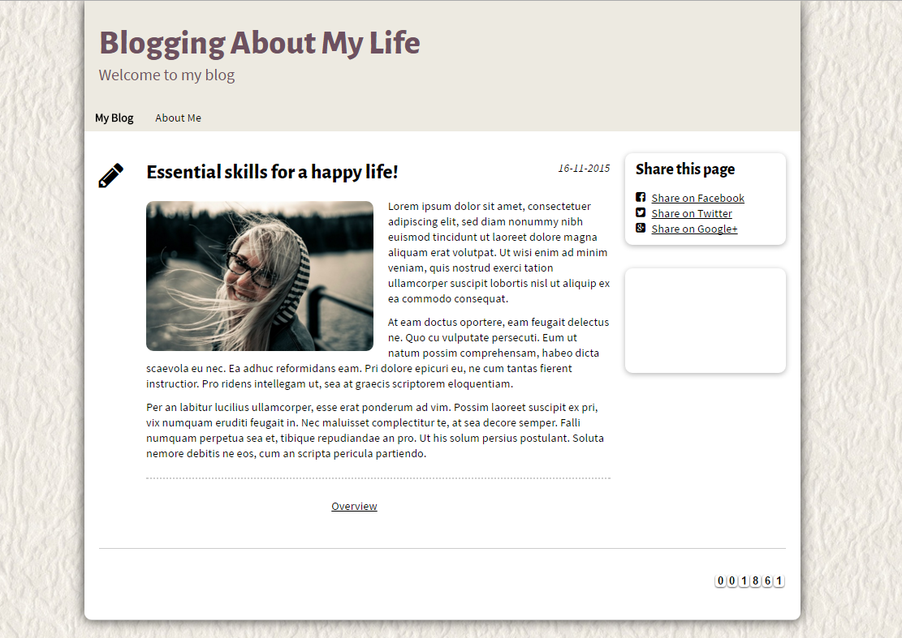

PIC 05 : About me Page
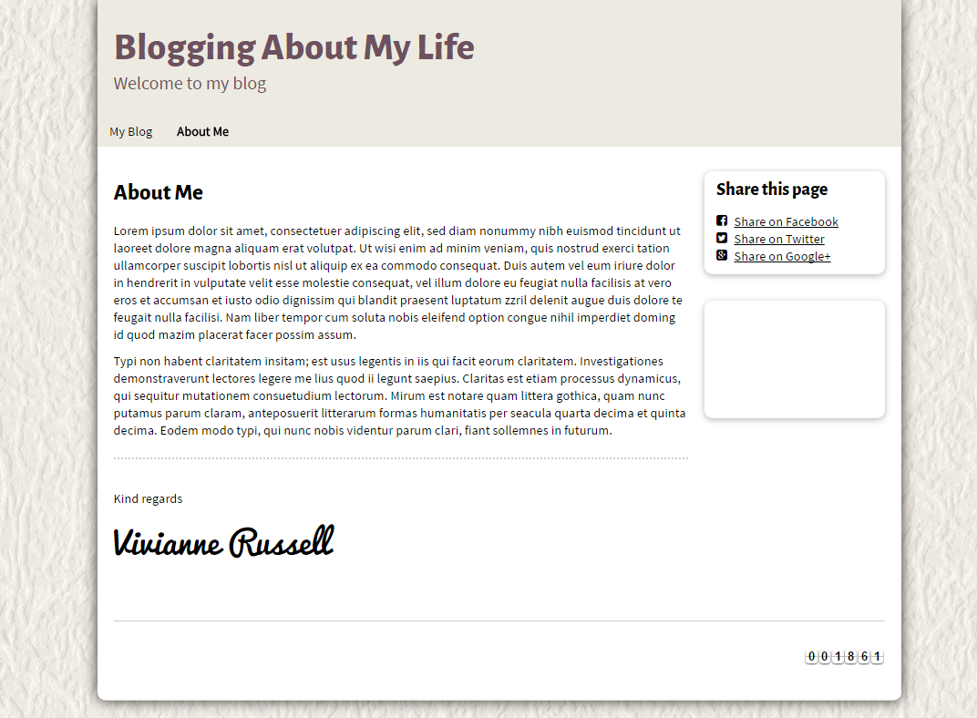

Guidelines
- Step 1 : verify requirement & scope with mentor
- Step 2 : Create prototype
- Step 3 : Design database base on created prototype
- Step 4 : Code & Test

